**Exercise 2.1**

1. **Implement and simulate the differential equations.**

This is the representation of the differential equations, using S = 500, I = 10, and β = 0.002, µ = 0.07, we can see how the susceptible population decrease as the infected increased, and then the recovered population become bigger as the infected population decrease. The second graph is the phase map.

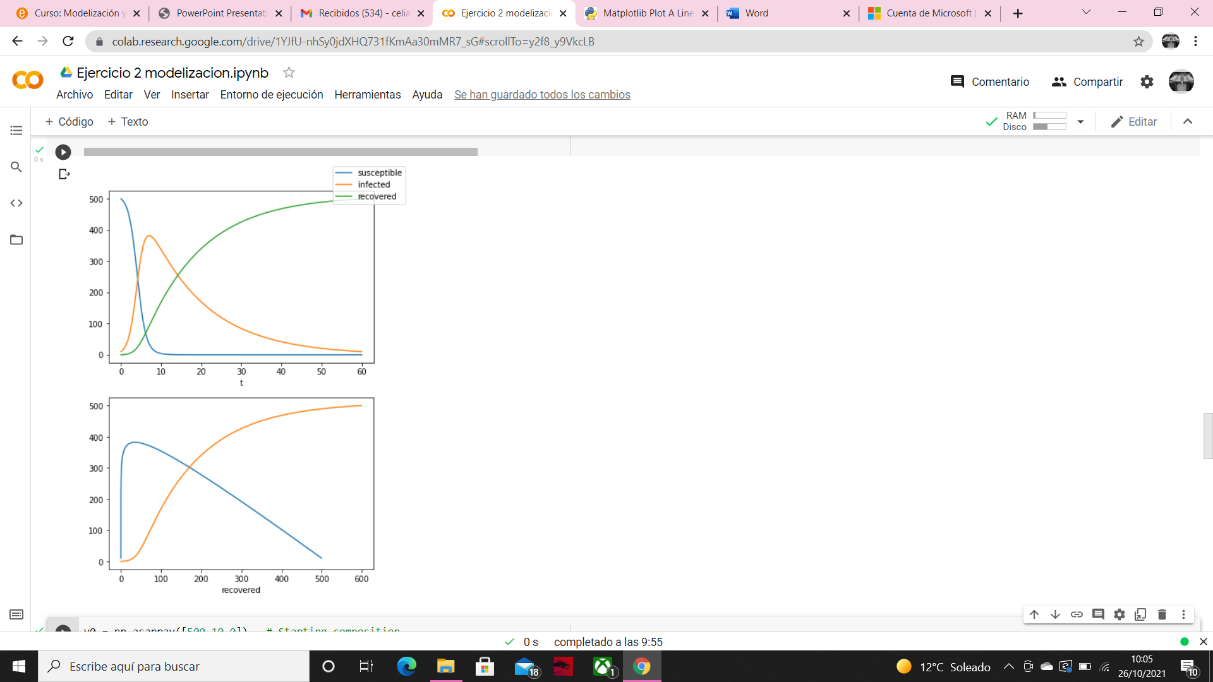

1. **Which parameters define the time scale in the system (about a year)? Play with them to find out how it changes.**

I have defined the threshold at 50 infected, with this parameters (S = 500, I = 10, and β = 0.0008, µ = 0.007) we can see that the time scale is very large, in order to make it smaller we can change the infection and recovery rates, and the susceptible population if we suppose that some part of the population is vaccinated. Moreover, it depends to on the initial infected population, we can consider this parameter too if we start to study the population when the disease is advanced.

If we reduce the infection and recovery rates, we see that the time scale is reduced too. Here the parameters are β = 0.008, µ = 0.07, the time scale is smaller because the infection is faster and the recovery too.

But if we maintain the infection rate at β = 0.008 and we reduce the recovery rate µ = 0.007 we can see how the time scale makes bigger again, with an increment on the population infected at the beginning and then a slow decrease of it.

Here we change the initial susceptible population, the maximum point is reached later, but the infected population reach the threshold sooner.

Changing the initial infected population we obtain a similar result at the first case, with a maximum point similar as the obtained before.

1. **Fix parameters above the epidemic threshold and change the initial conditions. Can you find endemic states? Plot the phase space of the variables (S,I) for several initial conditions.**

Epidemic will happen if infected population grows over time, so using the infected population differential equation we obtain that epidemic will occurs (dI/dt > 0) only if the initial susceptible population is bigger than the recovery rate divided by infection rate.

S0 > =

The reproductive ration will be the division of the susceptible individuals infected per day divided by the number of individuals infected by those. The reproductive ratio must be greater than 1 in order to disease expansion.

R0 =

That means that if we define β = 0.0008 and µ = 0.5 we need an initial susceptible population above 625, there will be infection. In the graph below we can see a little expansion of the disease, but then is eradicated easily, because S descend, and the conditions is not anymore true.

If we study the stability, using the Jacobian matrix based on the differential equations

= f(S,I) = - βSI J = =

= g(S,I) = I(βS - µ)

= h(I) = µI

We obtain two solutions, λ1 = 0, λ2 = βS - µ, so this system is going to be stable if βS is smaller than µ, or S0 < = . That’s why we cannot see stability at the beginning in the graph above but later we can see it. In the second graph we can see the evolution of the infected and susceptible population respect the infected and recovered population, the infected ones increase and then they become recovered population, with susceptible population, we can see that at the beginning they get infected and then recovered. Finally, in the phase space we can see how the susceptible population always get infected, and then the infected population disappears.

With a low expansion rate β = 0.0008, very high recovery rate µ = 3 and an initial susceptible population of 10000, we obtain an eradication of the disease with population that have not been infected.

With β = 0.5, and µ = 0.1 infected population increase rapidly because of the higher expansion rate and then tends to 0.

We can not find an endemic state because we are not considering new births so as the time past the infected population is going to decrease.

1. **Fix initial conditions and change parameters staying above the epidemic threshold. What is the maximum incidence of the disease? How does the maximum incidence and its time of occurrence change with the parameters?**

Parameters: S = 500, I = 10, and β = 0.0008, µ = 0.007

With a smaller transmission and recovery rate we can see that the maximum incidence reach almost the susceptible population and time of occurrence is very large, that is because the transmission rate affects more to the infected population than the recovery rate, as we can see in the differential equation dI/dt = I(βS - µ), where the transmission rate is multiplying S and I populations.

Parameters: S = 500, I = 10, and β = 0.0008, µ = 0.07

The maximum incidence is smaller here as well as the time of occurrence, because the recovery rate is higher so the infected population can not infect many people before they recover.

Parameters: S = 1000, I = 10, and β = 0.0008, µ = 0.07

The maximum incidence is higher because the increase of infected population is proportional to the susceptible population.

1. **Fix initial conditions and the value of the epidemic threshold, and change b and m with this condition. Do you see differences in the trajectories? Give a qualitative interpretation to the role of different parameters.**

Parameters: S = 500, I = 10, and β = 0.0008, µ = 0.007

Parameters: S = 500, I = 10, and β = 0.0008, µ = 0.07

Parameters: S = 500, I = 10, and β = 0.08, µ = 0.07

The trajectories of the susceptible population is similar in all cases decreasing to zero, in the last cases is more abrupt because almost at the beginning the susceptible population is all infected, because we have a similar rate of transmission and recovery.

With a lower µ (first case) the trajectories of the infected and recovery populations are more extended in time. In general, the trajectories are very similar, with little changes.

β = epidemic spreading

µ = decay rate

keeping the epidemic threshold R0 constant, the maximum incidence does not change. Therefore, the maximum incidence is solely determined by beta/mu.